1. **Life Path Number**

The most important and influential number in your personal Numerology is your Life Path number. This number represents who you are at your core -- the person you are spending this lifetime learning to become. It is derived from the numbers of your birth date and influences you all life long.

In some ways the Life Path number in Numerology is like the Sun sign in Astrology: it is an indicator of what is important to you, how you act and react, and how you process life. But do not think of it as a simple list of traits that are meant to tell you exactly who you are. While each Life Path carries a unique set of both positive and negative traits, how they manifest is up to you. Life will present you with many chances to flex the muscles of your Life Path number, but you will be the one to choose whether to take the high road or the low road in each situation. The choice you make and the consequences it brings will help guide you in your next decision and so on. Each experience is a lesson in how to become your highest and most authentic self.

**How to calculate your Life Path number**

Your birth date is made up of three parts -- the month, day, and year -- and your Life Path number is essentially a sum of these numbers. However, you can't simply add up the whole string of numbers in your birth date -- this method makes it possible to end up with a Master Number Life Path when there isn't one, or for a Master Number to not appear when it actually should. In Numerology, the Master Numbers are the 11, 22, and 33, and these, along with the single digits 1-9, are the only possible Life Path numbers.

There is only one correct way to calculate your Life Path number. First you must reduce each of the three parts of your birthday to a single digit or Master Number, then add up THOSE digits to find your Life Path number. If you end up with a two-digit number that isn't one of the Master Numbers, keep reducing it until you get to a single digit. Let's try one:

Say your birthday is October 22, 1980, or 10-22-1980.

*Step 1: Reduce the month*

From the number 10, you add 1 + 0 and the result is **1**.

*Step 2: Reduce the date*

22 is a Master Number, so we leave it as **22**.

*Step 3: Reduce the year*

1 + 9 + 8 + 0 = 18, which is still double digits and is not a Master Number, so we reduce it further. 1 + 8 = **9**.

*Step 4: Add the three resulting numbers and reduce them to a single digit or Master Number*

1 + 22 + 9 = 32.

3 + 2 = 5. **The Life Path for this birth date is 5.**

Now that you can calculate YOUR Life Path Number, read below for a quick look at what it means!

**The meaning of each Numerology Life Path number:**

***Life Path 1***

As an innovator and a pioneer, the 1 path is full of energy and motivation. These people are natural leaders and very capable of creating opportunity for themselves. Their lesson is to become genuinely confident in their abilities and practice trusting others.

***Life Path 2***

This is the path of the quiet but powerful influencer. These people are calm, cooperative, and understand the benefit of partnership. However, they must learn to speak up for themselves when their needs aren't being met.

***Life Path 3***

Creative and communicative, there's a youthful energy to a 3 person that is exciting to others. These people are upbeat and charming, but they have a lot to learn about the world. Accepting and exploring deep, difficult topics and emotions can help them on their journey of personal growth.

***Life Path 4***

The 4 Life Path is a practical one focused on service and hard work. These people are strong and stable and act as a rock in others' lives. Their lesson is loosen up their mind and methods and realize that love and enjoyment are just as important as duty.

***Life Path 5***

Life is an adventure to people with a 5 Life Path. They are curious individuals who crave variety and thrive in upbeat social settings. What they need to learn is commitment. A constant need to change their situation may ultimately lead to an unfulfilling life.

***Life Path 6***

These are the lovers, the nurturers, the protectors. The 6 path is blessed with a huge heart that allows these people to be of great support to others. In this lifetime, they must realize the importance of self-love and acknowledge that their own needs are just as important as others'.

***Life Path 7***

Exploring the mysteries of life gives the 7 path its purpose. These are very inquisitive people with an insatiable need to delve into any topic in search of answers and truths. However, they tend to be solitary creatures who have a lot to learn about relationships and vulnerability.

***Life Path 8***

Though people with a number 8 Life Path often find great success in life, it is not because of luck -- it's because of the constant attention, intention, and effort they put into their work. While they excel professionally, though, their ego needs some practice in working well with others.

***Life Path 9***

0116

***Life Path 11***

People with an 11 Life Path are unbelievably intuitive and may even exhibit psychic abilities. Their purpose is to use these gifts to better humanity. Confidence and worry are weak points for this path, so they will need to learn how to handle their unique powers.

***Life Path 22***

The 22 Life Path is called the "Master Builder" because it has a very special power to turn nebulous dreams into concrete realities. These people are spiritually connected and feel both a responsibility and a burden to use their cosmic gift to better the future of our world.

***Life Path 33***

Birthdays that add up to a 33 are very rare and these people are known as "Master Teachers." They are healers and great spiritual leaders devoted to showing others how to connect to their own heart and consciousness.

**2. Expression number**

Your Expression number is derived from your full name at birth, as it appears on your birth certificate. In Numerology, every letter of the alphabet is associated with a corresponding single-digit number. To find out your Expression number, write out the first name, middle name, and last name you were given at birth. If you don't have a middle name, then only use your first and last names. If you have more than one middle name or a hyphenated last name, include all of them. Then, use the chart to write down the number associated with each letter of your name. After that, add up all the numbers, then reduce the result until it becomes a single digit *or* a Master Number, 11, 22, or 33. That's your Numerology Expression number! Here's an example:

N   I   C   H  O  L  A  S        E  V   A  N        S   M  I   T   H

5  | 9 |  3  |  8 |  6  | 3  |  1 |  1 | 5  | 4 | 1  |  5 |  1  |  4  | 9  | 2  | 8

5+9+3+8+6+3+1+1+5+4+1+5+1+4+9+2+8 = 75

7 + 5 = 12

1 + 2 =**3, so this person's Expression number is 3**

Just remember, if any of your additions add up to 11, 22, or 33, don't reduce it any further! Your Expression number may be any number 1-9, or one of these three Master Numbers. Now that you know your personal number, keep reading below to learn its meaning!

**Expression number 1**

With a 1 Expression number, you possess strong leadership capabilities and a knack for creating your own opportunities. You will go where others are afraid to go and you'll make the journey look easy. The number 1's energy is extremely self-sufficient, allowing you to be most innovative and productive when you're working alone. You may even find it difficult to cooperate with others, preferring to do things your way rather than listening to anyone else's opinions. If you aren't careful, the 1 Expression could make you seem aggressive and self-centered. It's not in your nature to think before you speak or act, but you would be wise to learn this skill!

**Expression number 2**

Working with others is your forte. Your 2 Expression makes you very skilled in relationships of all kinds, because it is cooperative, supportive, and always striving for balance. You have a keen ability to read people and situations and react with patience and understanding. Others see you as peaceful and humble, yet there is great strength in you. Still, your feelings can be easily hurt and you have a tendency to doubt yourself when making decisions, which can make you idle. You would benefit from following your head instead of your heart from time to time.

**Expression number 3**

With the influence of the number 3, you are a naturally skilled communicator. You have a way with words and a great talent for conveying your creative ideas and inspiring others. Your social circle is strong and people find your optimistic attitude both magnetic and charming. However, the relationships you form, like many other things in your life, don't go very deep. Your enthusiasm for life can be a distraction, making you unable to stay focused on one person, job, or plan long enough for it to develop into something complete or meaningful.

**Expression number 4**

Organized, down-to-earth, and hardworking, the 4 Expression gives you skills that make you incredibly capable and constructive. You are a master at managing projects and teams and others rely on you because you follow everything through to completion. You are honest, patient, and loyal -- sometimes, loyal to a fault. The number 4 carries a stubborn, rigid energy that can make you so fixed in your ways that you are unable to grasp new, better ways of thinking, doing, and interacting.

**Expression number 5**

Your 5 Expression craves variety and freedom and wants to experience everything that life has to offer. You are an adventurous person who takes pleasure in trying new things and following your latest passion. Your passions change quickly, however, so you've learned to switch gears easily in order to explore as many possibilities as you can. Beware, though, that with all this change comes inconsistency. Your restlessness can make you unreliable in relationships and unprepared to handle the hardships of life.

**Expression number 6**

Your strengths play out most notably in your relationships with others. The influence of the number 6 makes you incredibly protective and nurturing toward all people, but especially your family members and other close loved ones. You have a heart of gold and feel a responsibility to be there to help those in need of support. It's important, though, that you don't forget about self-care. You can be so focused on the well-being of others that you neglect to attend to your own emotions and energy levels. Be kind to yourself, too.

**Expression number 7**

You are the truth seeker. You are energized by information and willing to go deep into both the intellectual and spiritual realms in search of real meaning. Logic drives the way you think and communicate, and this helps you clearly convey your vast knowledge to others. You are not satisfied with what's on the surface -- it's the hidden answers you are digging for. However, this assumption that there is always something to be found can make you suspicious of others. In fact, it may be hard for you to relate to other people in general; you tend to prefer a controlled environment where you can do things your own way.

**Expression number 8**

An 8 Expression blesses you with great business sense and excellent judgement of people, money, and plans. This is why you are able to achieve so many goals -- you know the best resources and the most attainable ambitions. You do run the risk of being too ambitious, however, and turning from an effective leader into an impatient taskmaster. While your drive to attain success and material wealth is powerful, it's important that you balance it with meaningful people, emotions, and experiences.

**Expression number 9**

Your 9 Expression is creative and compassionate and encourages you to find the best in everybody. Whether you're providing emotional support to a friend or engaged in a larger humanitarian effort, you strive to make life better for others. People see you as being friendly and affectionate, as long as you are immersing yourself in this altruistic work. If you are not living life in a way that is beneficial to other people, you could become self-centered and detached from important emotions.

**Expression number 11**

Having a Master Number 11 as your Expression blesses you with profound intuitive capabilities and an idealistic vision. You are driven by instinct and inspiration which give you a great, clear picture of the way things should be, yet you may lack the practical, organized thinking needed to bring your dreams to fruition. Still, your charismatic presence draws many people toward you who are in search of support, encouragement, and wisdom. You are a beacon of hope and light to those in need.

**Expression number 22**

Profound potential comes with a Master Number 22 Expression, which gives you a lot to live up to. In Numerology, this number is called the "Master Builder" because it is capable of constructing grand ideas and even grander realities. You are a cooperative team leader with a unique approach to solving problems and a desire to help others. You are headstrong and driven, yet this brings a risk of becoming so domineering that you lose the support of others. Remember that your goal is to create, not to destroy. You are in total control of your destiny.

**Expression number 33**

If your Expression is the Master Number 33, your mind and heart come together to make you an uplifting source of hope and healing. You have keen insight into the ways the world works, plus the creative communication skills to share this knowledge with humanity. Others turn to you to help guide them toward truth and inner knowledge -- you are an example of experience and enlightenment. Though it may often feel like you are burdened by other people's struggles, realize that you have been given these nurturing skills as a gift, and give of them freely.

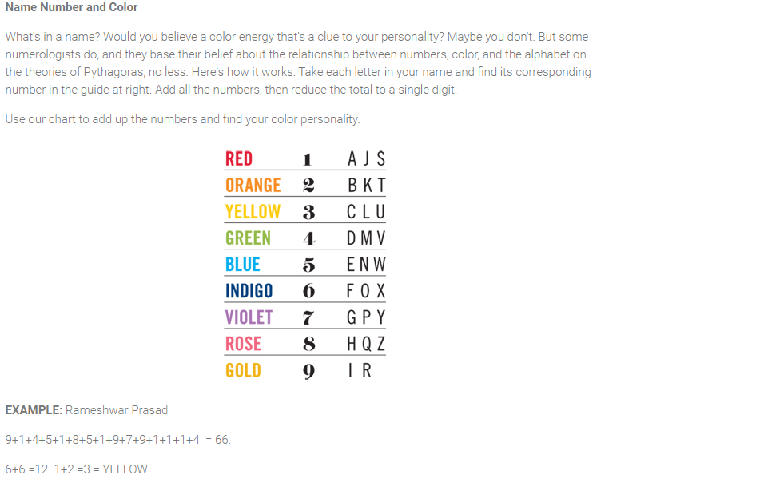

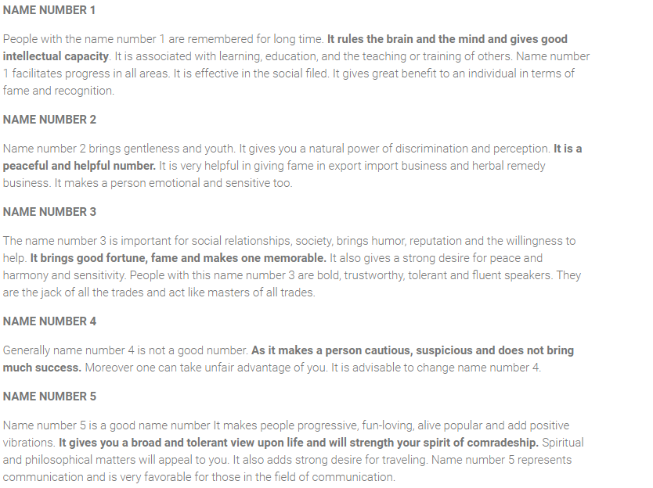

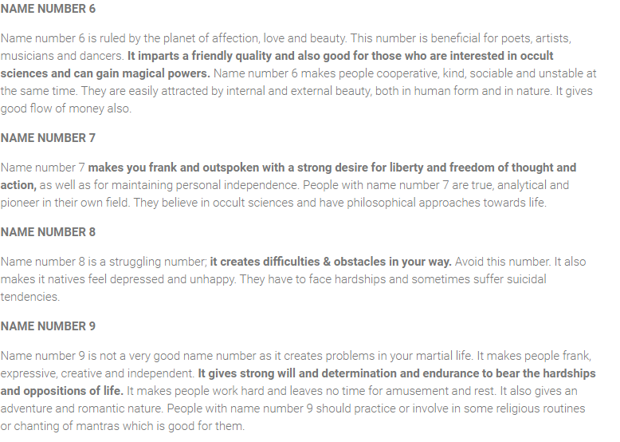

Yes

